**Day 5 - Testing and Backend Refinement**

|  |  |
| --- | --- |
| Functional Deliverables | **1-5** |
| LIGHT HOUSE REPORT | **5-6** |
| Documentation | **7** |

**Functionality Test:**

**Searching Product Test🡺**

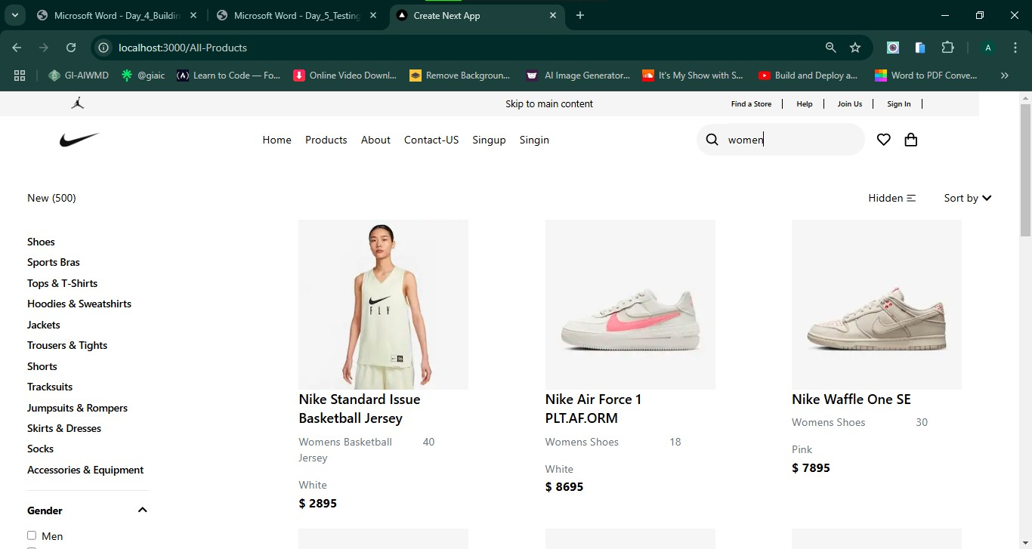

**Filter Product Test🡺**

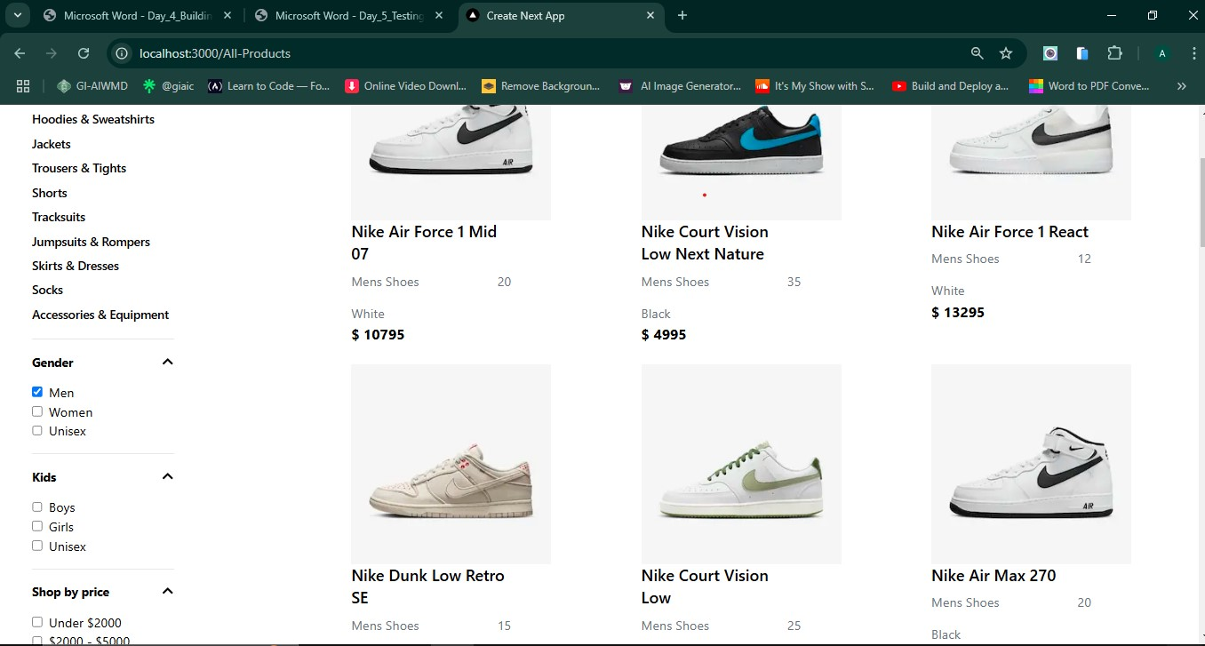

**Add to Cart Test🡺**

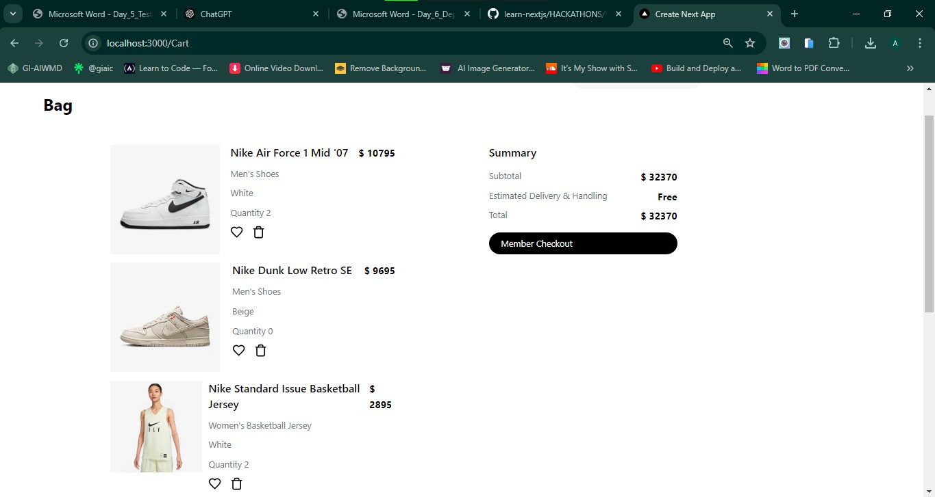

**Dynamic Routings Test🡺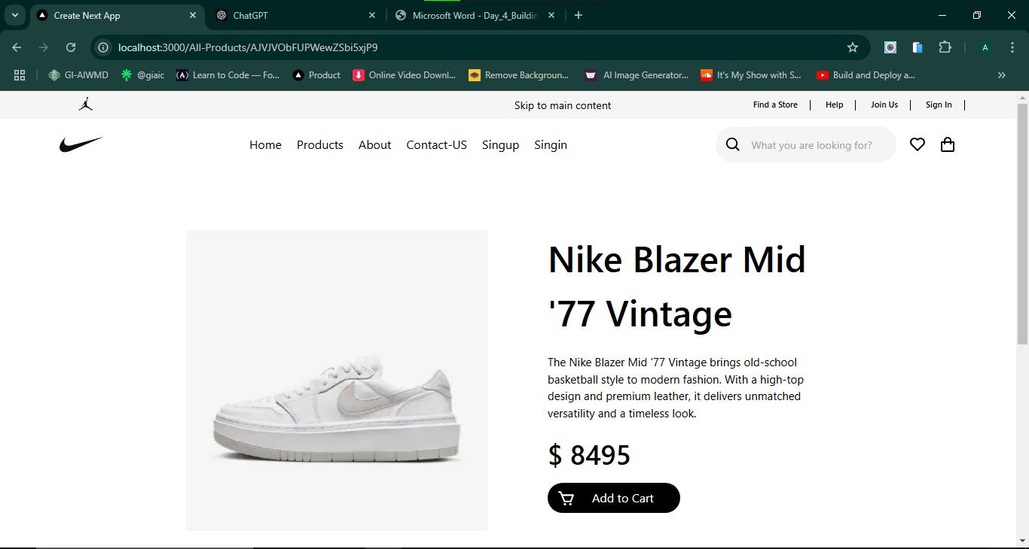  
  
Deleting Product form Cart Tests🡺  
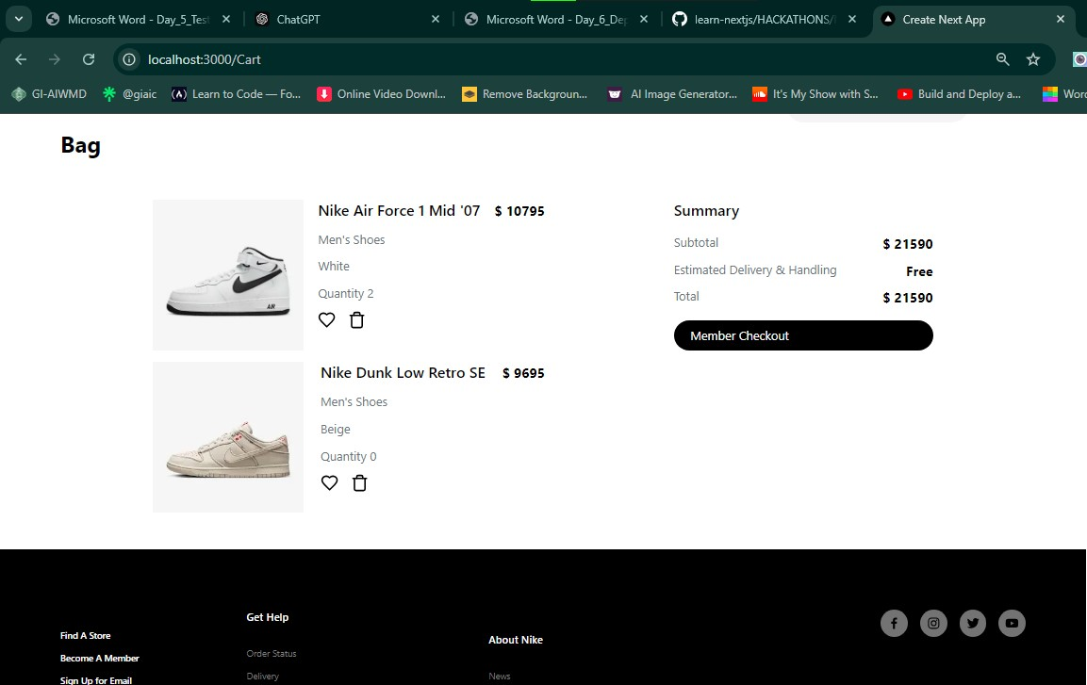**

**Responsive Test:  
Detail Product Page🡺** 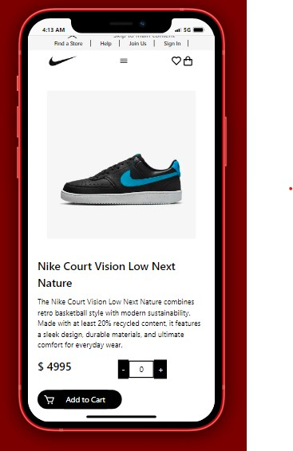

**Product Page🡺** 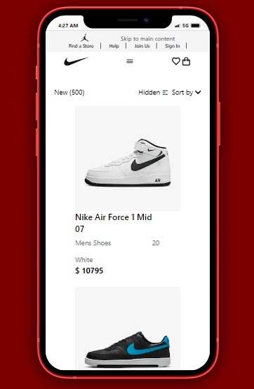

**Cart Page🡺** 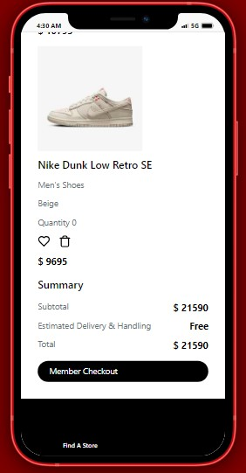

**LIGHT HOUSE REPORT:**

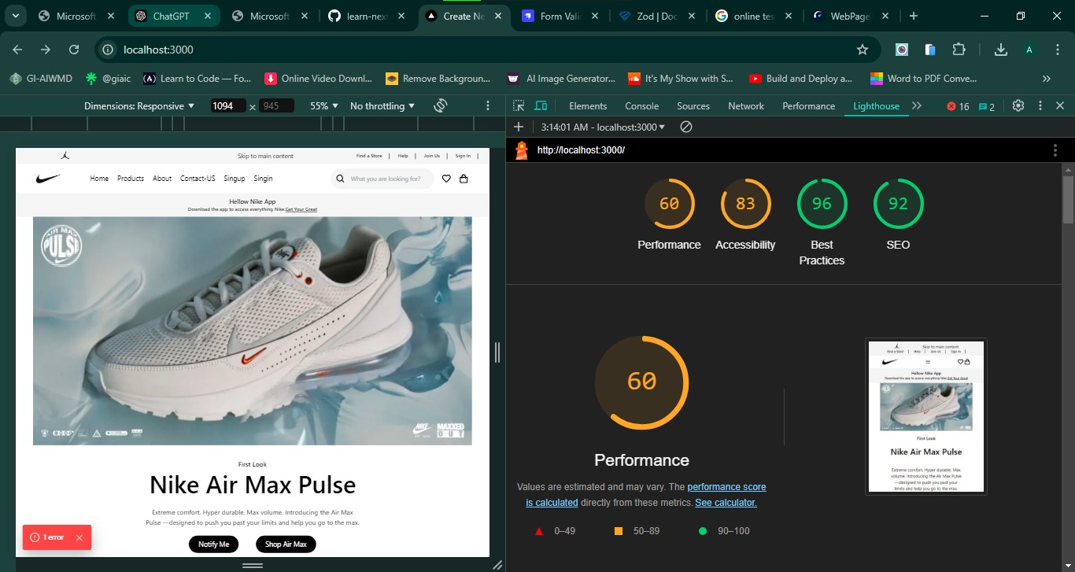

**Security Test🡺  
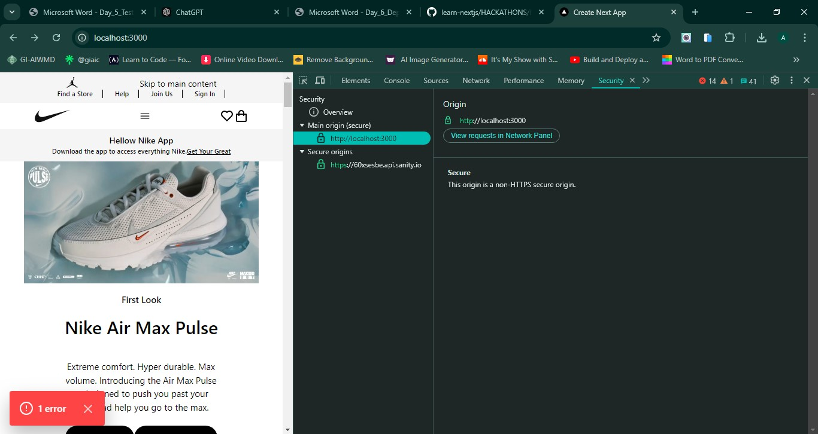  
  
Performance🡺**

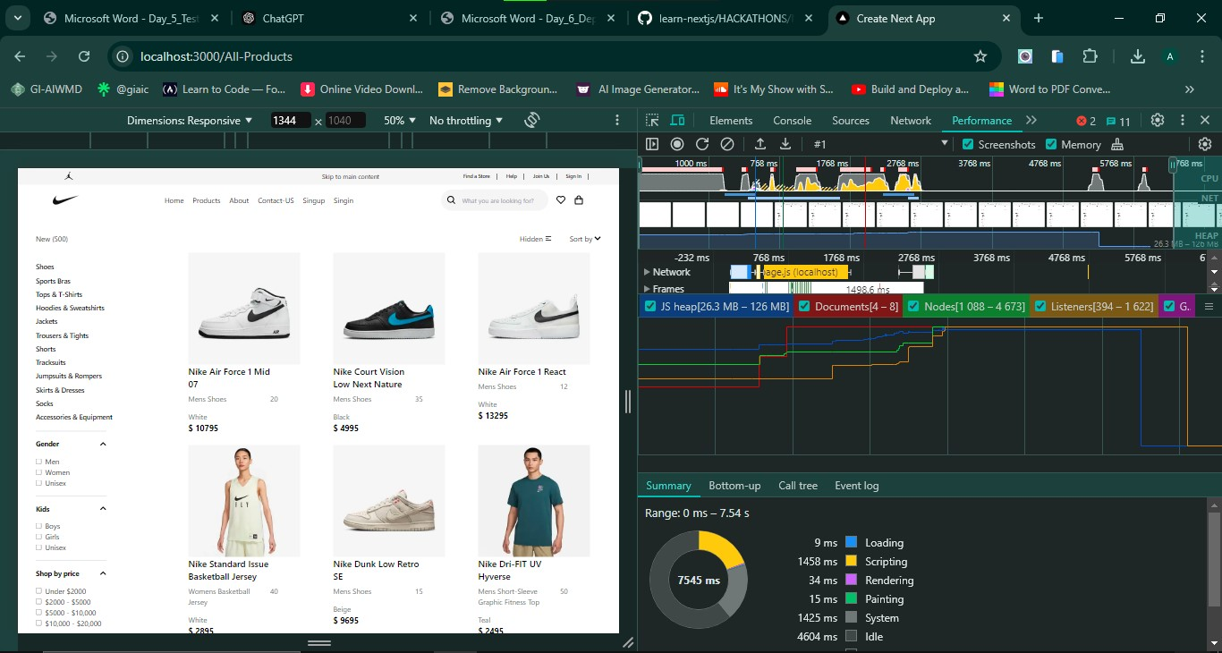

**Documentation:**

**1. Test Cases Executed and Results  
 API Tests🡺**  
 Fetch products (api/products): Passed  
 Post Data (api/Order):Faild

**UI/UX Tests🡺**  
 Mobile responsiveness: Passed  
  
 **Functionality Test🡺**Product Add to cart: Passed  
Dynamic Routing: Passed  
Delete Product From Cart: Passed  
Filter Product: Passed  
Search Product: Passed

**2. Performance Optimization:** I didn’t Understand how to optimize Performance

**3. Security Measures** Sanitized user inputs to prevent SQL Injection and XSS attacks.

**4. Challenges and Resolutions:** I didn’t face any challenges to using the Lighthouse for testing and getting result.